*SAVALI -- THE SPIDER’S VENGEANCE*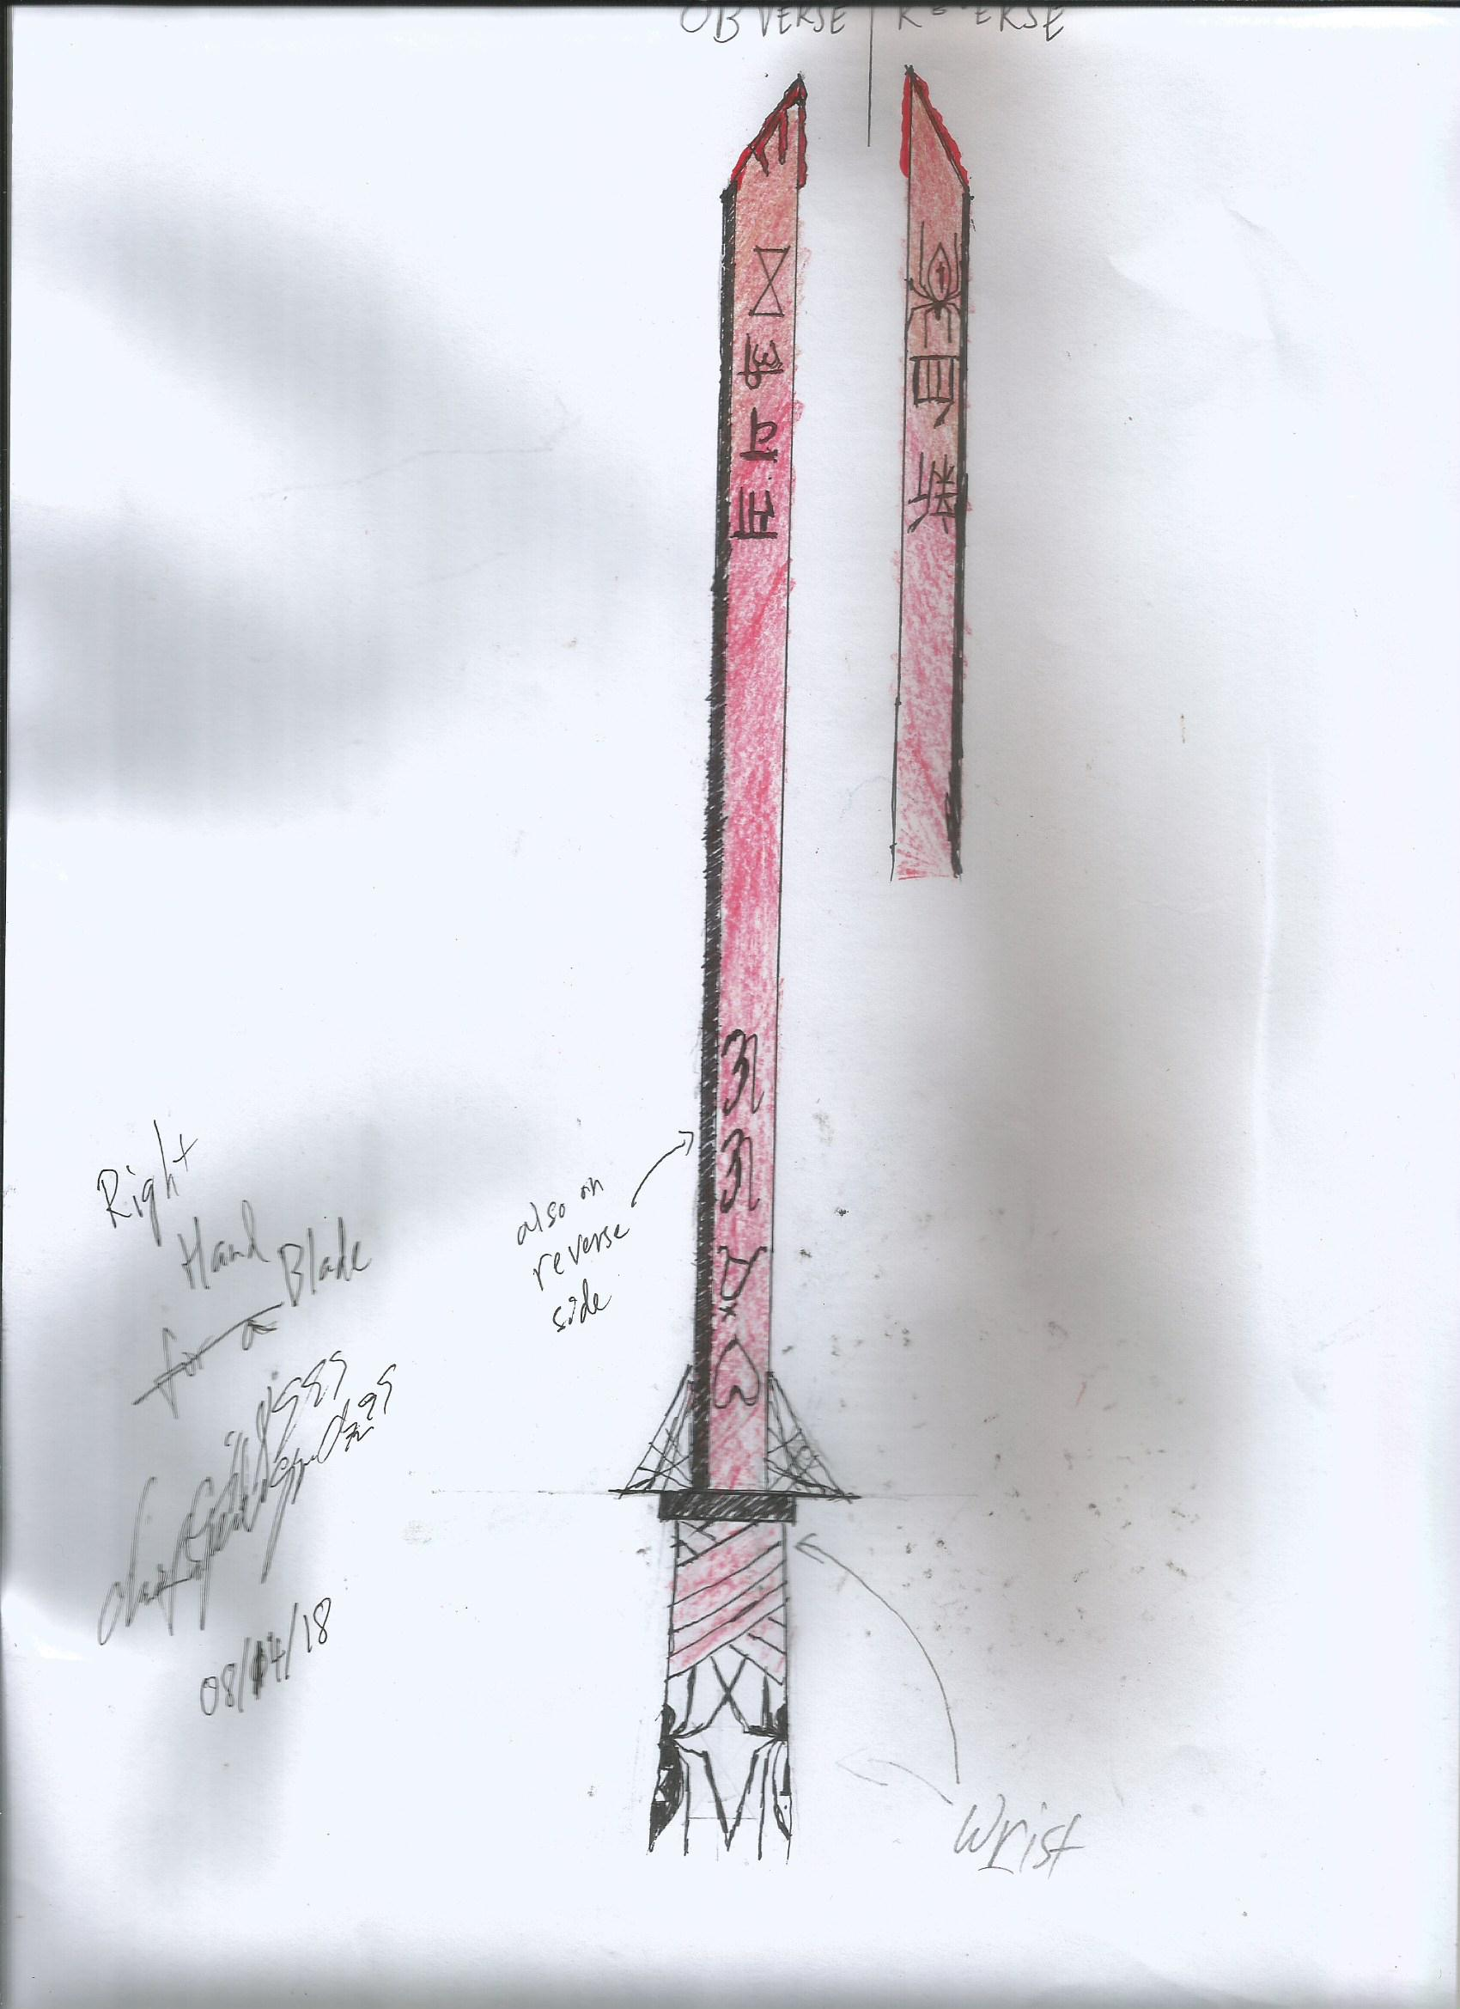

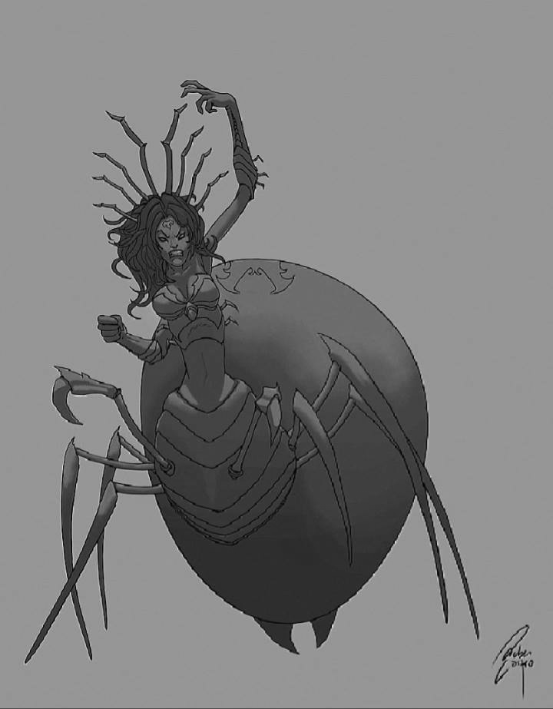

***FIGURES 1 & 2.*** *First picture is what Savali’s face and skin on her upper body could have looked like. Second picture is where her form now is based on. (source: DeviantArt. Artists: azinqe and Rucalok)*

Just a re-imagining of one of my former concepts, ever since I was inspired by *Kill la Kill*. Also, Erica Mendez.

**right hand is a blade instead of a “hand”, concept is really a spider centauride though :/ LoL needs more of them

BIOMETRICS

|  |  |  |
| --- | --- | --- |
| GENDER | F | |
| HP | 500 | 50 |
| HP REGEN (over 5s) | 1 | 0 |
| ATTACK DAMAGE | 64 | 8 |
| ABILITY POWER | 0 | 0 |
| ARMOR | 30 | 0 |
| MAGIC RESIST | 0 | 0 |
| ATTACK SPEED | 0.65 | 0.015 |
| CRIT. CHANCE | 0 | 0 |
| RANGE | 500 | |
| MVMT SPEED | 350 | |

LORE

*Savali is a ninja by blood, spider-human (arachne) by body, and demigoddess by nature. She was separated from her sister at the age of 7 as the Chosen Sacrifice to the Spider God, hand-picked out of all the girls in Valoran at that age. However, the god took interest in her, elevating her to a form higher than the spiders and their queen. Equipped with her newfound physique, abilities, and a bloodseeking blade for a right hand, she now exacts revenge on the woman that took her away from her family and plans to catch up with her long lost sister, she who has left the order to go rogue.*

SKILLS

*P: Blade of the Spider God*

Savali’s right hand is a blood red katana blade coated with her venom. Any enemy (champion, minion, or monster) struck by physical attacks get Widowmarked and take 16% AD damage every second for 4 seconds. If a Widowmarked enemy dies, Savali heals for 8% AD + 40% Lifesteal.

Widowmarked enemies do not receive another Widowmark unless the timeframe has elapsed.

She does not take lifesteal from basic attacks because of her blade-hand. Healing effects from external sources, health potions and health regen items are only 4% effective on her.

*Q: Blood Skewer*

Savali’s blade hand is extendable, piercing up to 4 enemies before retracting. It deals (10/20/30/40/50 + 25% AD + 50% Lifesteal percentage + 5% of her missing health) physical damage to the first enemy struck. Damage decreases by 20% for each enemy pierced beyond the first. She heals for 8/10/12/14/16% of the total damage dealt.

Cast range: 550; CD: 7/6/5/4/3 seconds

*W: You and What Army?*

Savali summons 2/3/4/5/5 spiderlings to her aid. Each spiderling has 20 + 20% AD + 50% Lifesteal percentage HP and deal 10 + 5% AD + 25% Lifesteal percentage damage to an enemy (prioritizes minions and monsters). Each level-up enhances spiderlings in some way:

Level 2: Spiderlings gain 10% more HP and an additional 20% damage

Level 3: Spiderlings gain more attack speed and movement speed based on Savali’s missing health (up to 50% bonus AS and 30% MS upon taking lethal damage).

Level 4: Savali heals for 15% of the damage each spider deals.

Level 5: Savali can detonate her spiders at will (read: W second cast) dealing 3 + 3% AD + 8% Lifesteal percentage damage to enemies within each spider’s range and Widowmarking all of them. Enemies can receive multiple hits from different blasts, and each successful hit restores 8 HP to Savali.

Spiderling / Blast range: 250; Spiderling attack speed: 0.75; Spiderling movement speed: 350; CD: 18/17/16/15/14 seconds

*E: Shadow Skitter*

Passive: Savali gains 10/12.5/15/17.5/20% Movement Speed bonus

Savali blends in the shadows, turning invisible for 3/3.5/4/4.5/5 seconds or until she attacks and enemy. While invisible, Savali’s movement speed bonus is doubled.

If Savali uses Blood Skewer within 5 seconds after exiting the shadows, she heals for another 22/24/26/28/30 + 40% Lifesteal percentage damage.

CD: 16/15/14/13/12 seconds.

*R: Weaver’s Trap / Shitzuchi Technique*

Savali spins webbing for 0.5 seconds and throws it at a nearby area. Any enemy, minion or champion, that is caught within range is immobilized for 1.25 seconds while any enemy that tries to enter is slowed by 20%.

For the next 3 seconds, Savali can cast *Shitzuchi Technique* at the cost of her health, blinking to enemy champions within the webbing and dealing (10/20/30 + 30% AD + 40% Lifesteal percentage + 15% of her missing health) to each one. Savali heals for 40% of the damage dealt per champion struck.

Casting range: 650; Webbing range / area: 800;

COST: 10 HP / 15% HP CD: 110/100/90 seconds

VOICE LINES (sample): (#becausematoiryuko)

* Selection: “Oh it’s… you. *sigh* Fine! Let’s just get this over with!”
* Banned: “Who… DID THIS?! WAS IT YOU?!”
* Walking:
  + “I should get used to walking on eight legs.”
  + “*warbles* Don’t get pissed at the world. DAMMIT! ”
  + “If only my sister were watching this…”
  + “Don’t lose your way!”
* Attacking:
  + “I need blood, FRESH BLOOD!”
  + “Take this!”
  + “And that!”
  + “Did you need that head?”
  + “I enjoy watching you die a slow and painful death.”
  + “Witch.”
  + “I’ll rip out your innards!”
* Q:
  + “Shish kebab! Yummy.”
  + “Did that hurt? I DON’T GIVE A DAMN!”
  + “En garde!”
  + “Thrust!”
* W
  + “This army I have right here.”
* E
  + “Nyehehehehe!”
  + “You’ll never see me coming.”
* R
  + “SHITSU-CHI!”
  + “Is this loss… blood loss?”
  + “I FEEL FULLY ALIVE.”
  + It’s called K.S., dearie! Live with it.
  + “Chop, chop chop!”
* Upon meeting Elise (Allied)
  + “Oh! Now I get it! You want me and this witch to work together and destroy the enemy nexus! Well, YOU KNOW WHAT?! FINE!”
  + “Calm down, Savali. It’s just for this game only.”
  + “AWWW, NOT AGAIN!”
  + *grumbles*
* Upon meeting Elise (enemy)
  + “YOU… WITCH!”
  + “DAMN YOU! DAMN YOU ALL!”
* Upon getting First Blood
  + “BLOOD!”
  + “Yes!”
* Upon dying to First Blood
  + “NOOOO!”
  + “My… blood…”
* Death animation: Dissipates into threadlike substances, her sword hand is the only thing left..
  + “Unnhh…”
  + “No…”
  + “Why me?”
* Double Kill:
  + “Two down”
* Triple Kill:
  + “Three down”
* Quadra Kill
  + “Four down.”
  + “One more to go.”
* Pentakill
  + “You’re finished.”
* Upon scoring an ace
  + “Ahh, peace and quiet.”
* Upon taking a buff / Rift Herald / Baron Nashor / Elder Dragon
  + “Thanks!”
  + “Oh, I’m sorry! Needed that?”
* Dying immediately after taking said buff / RH / ELDR/ BR
  + “#*&*$!” (loud bleep)
  + “Ouch.”
* Buying boots:
  + “Do you have six more of those?”
* Meeting allied Akali
  + “Sister, don’t you recognize me?”
  + “Sister, how long?”
  + “Vile’maw’s actually kind, y’know.”
* Attacking Akali
  + “I hope the Order you left taught you well, sister”
  + “Going rogue is a bad idea, sis.”
  + “Now you deal with me!”

Kill la Kill references incoming!

* Upon meeting Lux (very subtle reference)
  + “You seem familiar, although you were more… serious and dark haired, back then.”
* Upon attacking Jinx:
  + “What?!” (tried to insert obligatory *nani sore* joke here)
  + “I can scream all I want!”

(more to follow soon)